Quick Reference Card Approving timesheets by the project manager
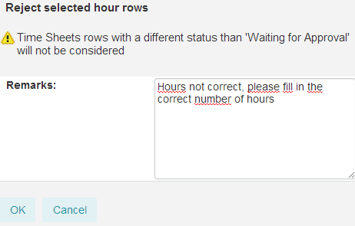
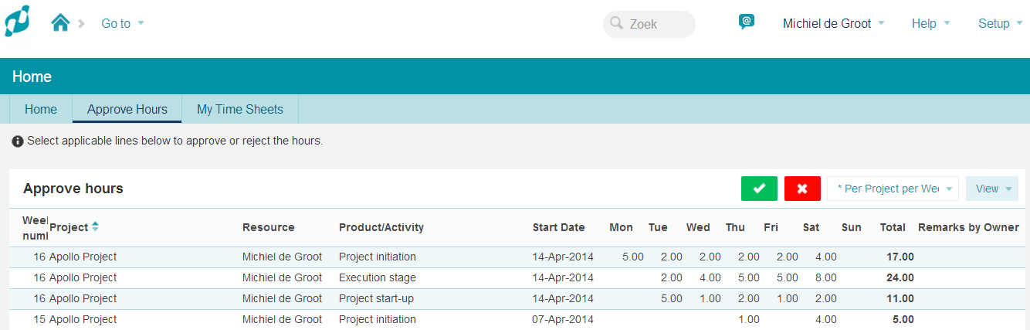
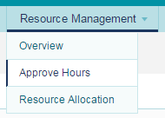
4

A project manager can approve hours on his project on his homepage under the tab Approval of hours

- Select the row(s) with hours that have to be approved or rejected.

- Click the green checkmark to approve the hours.

- Click the red cross to reject the hours. A pop-up appears. Enter an explanation and click OK. The timesheet will now be returned to the author (with the explanation).

- A project manager can also approve hours in his project under the tab Resource Management, Approve hours. This is done in the same way as described above.

3
1
1
3
2
General
Users of the Principal Toolbox can enter hours in timesheets. The hours are, depending on the chosen process, approved by the project manager and/or the line manager. This QRC describes the approval by the project manager and the approval by the line manager.
N.B.: If the option ‘automatic approval’ is flagged, this QRC is inapplicable.
Quick Reference Card Approving timesheets by the line manager

The homepage of the line manager displays an overview of the timesheets that are waiting to be approved.

- The timesheet marks the hours that are waiting for approval with a blue line on the left.

- Click the green checkmark to approve the hours.

- Click the red cross to reject hours. Enter an explanation in the pop up screen that appears and click OK. The timesheet will now be returned to the author (with explanation).

- These green checkmarks indicate that these projects are approved by the project managers(s). If there is no checkmark, approval by the project manager is not necessary.

A line manager can also approve timesheets through the time entry module. Go to the time entry group. The tab timesheets displays an overview of the timesheets.

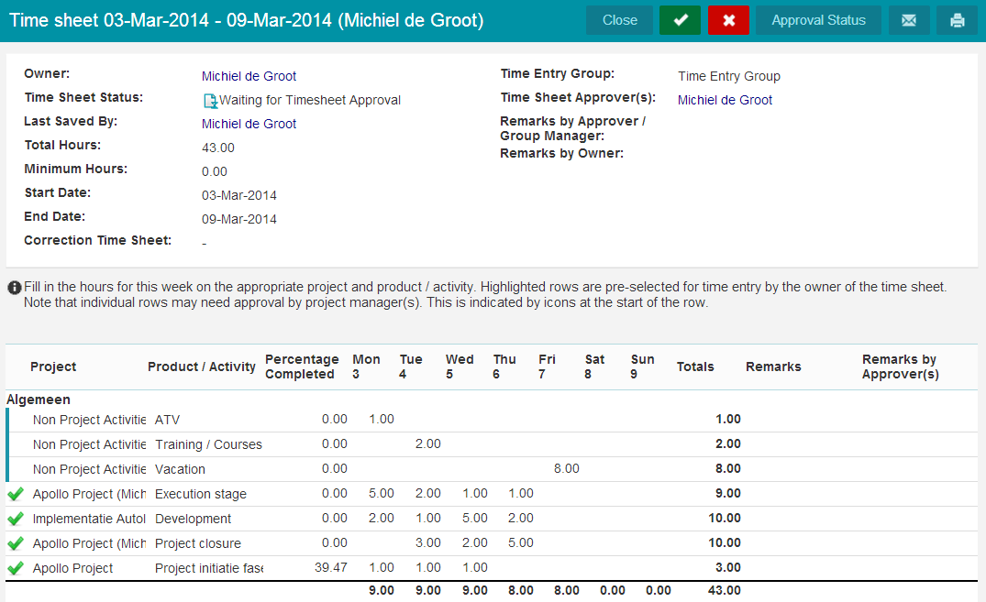
1

2
3

4

Quick Reference Card Reopen a timesheet

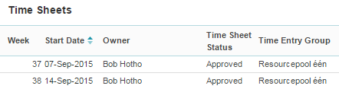

If an approved timesheet needs to be adjusted, a line manager can reopen it.

- Go to the OU with Time Entry. On the tab Resource Management, subtab Time sheets, open the time sheet in question. A pop-up appears.

- In the pop-up, click Reopen. Another pop-up appears.

- In the pop-up you can add a remark, then click Reopen.

The employee can now change the timesheet and then submit it again for approval.

Note:
At the instant of approval a timesheet generates entries. After reopening a timesheet, at the instant of approving it:
- the earlier entries are counter booked
- new entries are booked

2

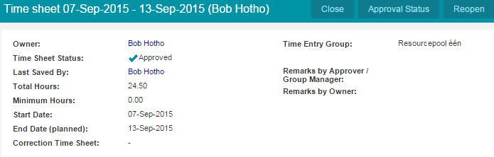

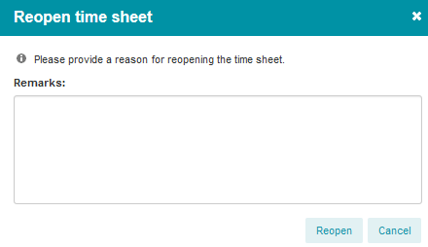

3

Under the help button you can find the  user manual and an overview of shortcuts.  Release 8.5 www.principaltoolbox.com | 