

***Quick Reference Card*** *Enter and submit a timesheet*

1. The general data of the timesheet. This displays the minimum amount of hours to justify and the status of the timesheet. (See legend at the bottom of the page).
2. When hours have to be approved by both the line and project manager, a doll icon  will be displayed next to the project.
3. A timesheet can be configured to display a pre selection of projects and products .These rows are marked by a green line on left. The timesheet can, by definition, only show the projects and products of which the user is a team member or owner.
4. A timesheet can be configured in such a way that projects and products are selectable. The user can choose from projects in which he has a role. The selection will be shown on the next timesheet (for convenience).

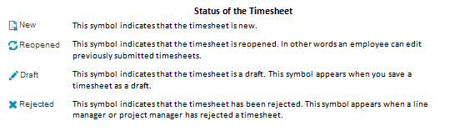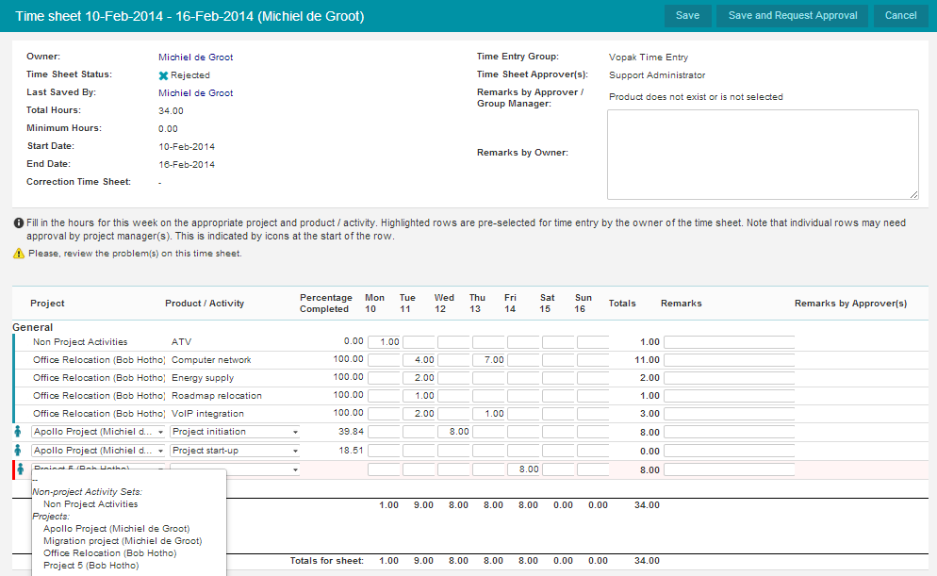

**10**

1. Also you can enter hours on ‘*Non Project Activities’*. In the first drop down menu choose Non Project Activities, next select the appropriate activity in the second list.
2. Click **Save** to save the timesheet as draft and continue working on it later.
3. Click **Save and request approval** to submit a timesheet.  
   **N.B.**: if no approval is needed because ‘automatic approval’ is flagged, click **Save and Close.**
4. It is required to choose a value in both menus. If you forget one a red bar will appear on the timesheet when clicking **Save and request approval** (or **Save and close**).
5. The second drop down menu shows (**‘On project’**) when it is configured that hours are booked on project level.
6. Here you can add a remark per line.

**8**

**2**

**9**

**5**

**4**

**3**

**6**

**7**

**1**



***Quick Reference Card*** *Adjusting a rejected timesheet*

1. The symbol  is shown when hours on a timesheet are rejected.
2. This blue checkmark indicates that the hours are approved.
3. This red cross indicates which hours on the timesheet are rejected.
4. Here you can correct the rejected hours and click Save and request approval to resubmit the timesheet.
5. This column shows the comments of the reviewer (if available) concerning the rejected hours.
6. In this column the employee can add remarks concerning the registered and/or adjusted hours.

**Reopening a timesheet**

If an approved timesheet has to be adjusted, the time entry group manager can reopen the timesheet: Navigate to the time entry group, open the timesheet, click **Reopen** and click **OK**. The employee can now edit the timesheet and request approval anew.

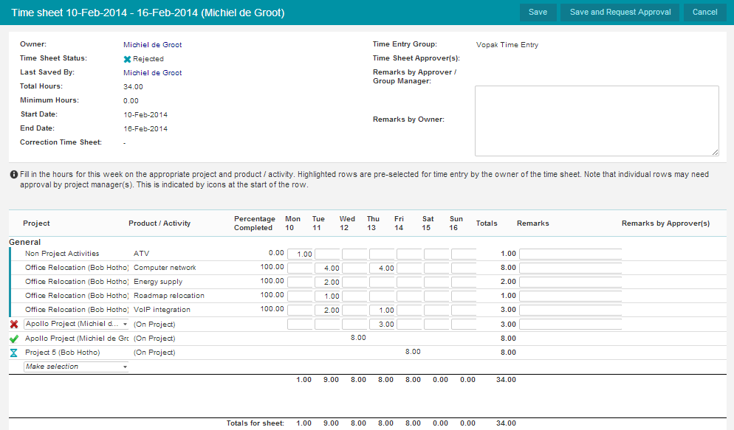



**1**

**2**

**5**

**6**

**4**

**3**



|  |  |  |  |  |
| --- | --- | --- | --- | --- |
| Under the help button you can find the user manual  and an overview of shortcuts.  Release 9.5 [www.principaltoolbox.com](http://www.principaltoolbox.com) |  |  | With the Fortes app you can enter timesheets on your tablet or mobile |  |