Quick Guide
Portfolio Management Adding ideas
Adding ideas
- Go to the tab Ideas. Click on one or more times to add ideas.
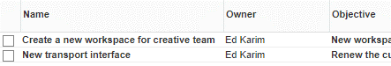
- Enter data in the rows and click Save.

NB: you can use the field Owner to allocate write rights on ideas.

Starting an initiative / a project
Starting a new initiative
- Select a portfolio and click in the section Portfolio items.
- Enter the details and select Initiative and click OK
- By using the selected checkbox you can show or hide the initiative on the portfolio dashboard.

Starting an initiative from an idea
- Click on the name of an idea to open the details page.
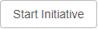
- Click on Start Initiative in the top of the details page.
- Select the appropriate portfolio and select an owner. Click OK. The initiative is now available in the portfolio.
- If the checkbox selected is checked the project will be shown in the project dashboard.

NB: from one idea multiple initiatives can be started.

Starting a new project
- Select a portfolio and click in the section Portfolio items.
- Enter the details, select project and select the OU, select the right folder, select the project model to be applied.
(see in this QG: Availability of the Project model when starting a project)
- If the checkbox selected is checked the project will be shown in the project dashboard.
- Select the project manager and click on OK to start the project.

The project is now available in the defined portfolio and the defined folder. The project manager is now able access the project.

Starting a project from an initiative
- Select a portfolio and click on the name of the initiative to open the details page.
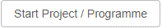
- Click Start Project in the top of the details page.
- Select the project model to be applied and select the right Folder.
- If the checkbox selected is checked the project will be shown in the project dashboard.
- Select the project manager and click OK to create the project.

Availability of the Project model when starting a project
When you start a project you first have to select the OU and a Folder.
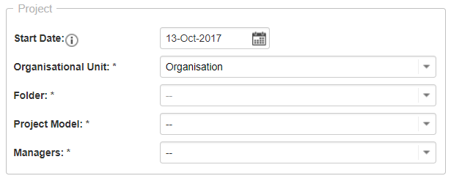

Based on the selected OU and folder the following project models will be available:
- All models in the selected folder (Model saved in this folder)
- All models in the folder above the selected folder in the same OU (Model saved in above folders in same OU)
- All models in this the selected OU (Model saved in this OU tab Models)
- All models in above OU’s (Model saved in OU tab Models)

The following Project models will not be available:
- Models saved in the folder next to the selected folder (model saved in that Folder)
- Models saved in a folder in a OU above the selected OU (model saved in a higher OU in Folder)

Required fields
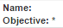
Required fields (e.g. on the tab Properties or on a log-item-page) are marked with a *. Pages with required fields on them can only be saved when those fields have been entered.

NB: There is also a possibility to set conditional required fields. The required field then depends on the value of another field. Conditionally required fields must be activated in the advanced system settings first.

Editing data in the portfolio dashboard
The project is now available in the applicable Portfolio in the Portfolio Dashboard and in the program/department. The project manager is now able to start the project. data in the portfolio dashboard
A portfolio dashboard shows a list of all the projects and initiatives. In this list you can:
- Change which information is shown: in the section Portfolio items, click View. See below for more information on working with views.
- Open the item card: click on the name of the portfolio item.
- Edit the information of portfolio items: in the section Portfolio items click on .
NB: The Portfolio Dashboard is also available on the Custom Dasboards.

Working with the portfolio Gantt
Navigate to the Gantt tab in a portfolio. All portfolio items are shown here, different types are referred to with different colours:
Several functionalities are available here:
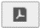 Generate a PDF of the portfolio Gantt. If a filter is used on the portfolio Gantt, that filter will be also applied
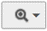
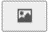 Generate an image of the Portfolio Gantt Zoom Options. Zoom In, Zoom Out or Zoom Fit to adjust the display of the portfolio Gantt.

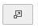
Maximize the portfolio Gantt on full screen.

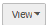
Click View, Columns to select columns displayed in front of the Gantt. Click Save as to keep the view for future use. Views can be managed using Manage views. The critical path will be displayed in red when you click on Show critical path.
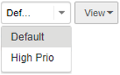
Change the view shown to display the Gantt. Only the default and the saved views are shown here

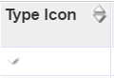
Note: The sorting of the column items in front of the Gantt can be adjusted by clicking on the header. Change the order of columns by using drag and drop. The width of the columns and the Gantt can be adjusted by dragging and dropping the borders.

Note 2: Click on the timeline to adjust the scaling of the Gantt. Left click to Zoom in, right click to Zoom out.

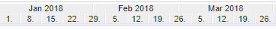

Click 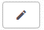 in order to:
- Add new initiatives to the portfolio using the icon on the left site of the Gantt. Start and end date of initiatives can be changed by adjusting the green bar in the Gantt. This can also be done in the columns.
- Remove initiatives by clicking 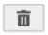 in front of the initiative.

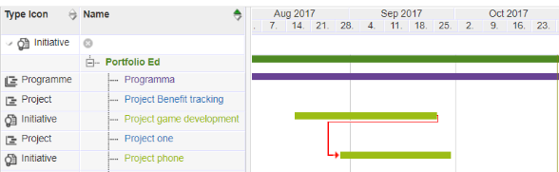
- Select items with the checkbox in order to add dependencies or remove dependencies . Dependencies will become visible with black or red arrows. Red indicates a dependency conflict. Use to adjust the planning so conflicts are solved.

Scenario planning: making and applying scenario’s
Create and save a scenario planning:
- Go to a portfolio, tab Scenario Planning
- Select portfolio-items you wish to add to your scenario.
- You can save different scenarios with the Save Scenario button.

Calculate a scenario
Set conditions under the Configure button.
- Enter one of multiple fields under Maximise. Enter a target value that at least should be reached by the selection of projects.
- Enter one of multiple fields under Constraints. Enter a target value that most may be reached by the selection of projects.
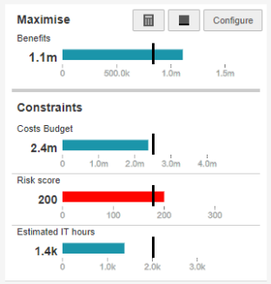
Use 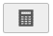 to calculate the scenario based on given criteria. Use to set baselines, visible with a black line under the bar. If the bar is green, the criteria are met. If it is red, criteria are not met.

Apply a scenario planning
The button Apply to Portfolio ensures that only those projects are visible in the portfolio that have a check in the stored scenario.

Note: The scenario planning functionality is switched off and on by the administrator.

Sending a report request
You can send report requests to (a selection of) projects/initiatives in the portfolio.

- Go to a portfolio. Select the items that have to report to the portfolio. Use Ctrl or Shift to select multiple items.
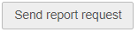
- In the section Portfolio items, click on Send report request.
- Select a due date and the report model to be used.
- Confirm with OK.

The project manager can now fill out the portfolio report and publish it to the portfolio.

Note 1: When sending a report request to single sheet projects, the request will become the page where the entire project administration will take place.

Note 2: In projects with a portfolio link the financial grid can be found on the tab Portfolio Report and the tab Financials.

Monitoring report requests
In the section Portfolio items you can monitor the status of report requests. Select an appropriate view which contains the column Report status. This column shows:
= a report request is past the due date, but hasn’t been published yet.
= the report request has been published to the
portfolio by the project manager.
= a report request has yet to be published by the project
manager (but is not yet overdue).

Save a version of a portfolio
You can save a version of a portfolio. The data in these versions can be consulted and can be used in reports.

Saving a version of a portfolio:
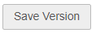
- Go to a portfolio.
- In the section Portfolio items, click on Save Version.
- Enter a name and add remarks if necessary.
- Confirm with OK.

Saved versions can be found in the Portfolio dashboard in the section Saved Versions. Click on the name to open a version.

Automated reports and ad hoc reporting
With Fortes Change Cloud you can create reports/documents based on templates. The available templates can be found on the Dashboard tab in the Automated Reports framework and on the Reports tab.

- Click the name of the report.
- Warning: Excel reports must always be saved before opening.
- Allow macros (so that the report will fill with data).

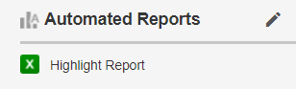
WARNING: Macro security settings in MS Excel should be set on medium or higher in order for automated reports to work properly.

In the tab Report, section Reports you can create ad hoc reports using views (see below for working with views). The section Shows the available ‘objects’ on which you can create reports.
Current Financial Period
In the Portfolio model or in the relevant Portfolio you can set the current year. When a new year begins you can choose to change the current financial Period. So you can see the correct financial grid. See QG: Financial configuration, for more details.

Notify Stakeholders
By using the Dashboard Report you are able to send a report based on widgets to stakeholders.
Creating a dashboard report

- Go to a portfolio, to the tab Dashboard Report
- Click and then to add a widget
- Choose a widget, click Save
- Then click Notify Stakeholders, select the stakeholders and then click Notify Stakeholders
Archiving projects (in a portfolio)
Note: projects have to be archived in the portfolio and also in the Folder; this makes it possible to archive projects in programs and portfolio’s separately (in time) from each other.

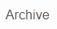
- Go to a portfolio.
- In the section Portfolio items select the row of the project that you want to archive.
- Click Archive and confirm by clicking OK.

Note 1: Achieved projects are shown in the financial grid if they contain entries for the period shown. If you would like to change this, ask you Administrator to change a setting in the financial configuration.

Note 2: Projects should be archived separately in the portfolio and the Folders. This is because projects are often archived in the program in an earlier stage compared to the portfolio.

Sending notifications from the portfolio
Sending email from the portfolio
You can send email notifications directly from the portfolio to the project manager of a project (for example when a report request is overdue).

- In the section Portfolio items, select the project you want to send a notification by clicking on the appropriate row. Use Ctrl or Shift to select multiple projects.
- Click on 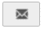 and enter your message in the pop-up screen.
- Click on OK to send your message.

Fortes Change Cloud sends the message as an e-mail to the project managers of the selected projects.

Note: the e-mail address of the user has to be entered correctly in the user administration of the Fortes Change Cloud.

Using the notification function
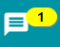
Send notifications to another user by using @ followed by the name of your colleague.

Send notifications to a project by using # followed by the name of the project.

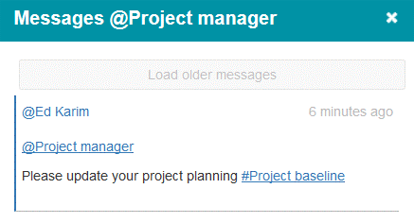

Working with views
On tabs, reports and logs you can change and save views. Clicking on View shows the following options:
Set Filter : define a filter for the view
Set Columns : define the columns in the view
Set Widths : change column widths in the view
Chart Options : show the view as a chart
Advanced : extra settings (e.g. totals)
Make Default : make a view the default view
Save View : save the view
Manage Views : manage the properties of views

Click on Set Columns
- You can add or remove columns in views by means of drag and drop. The sequence of columns in the view can also be adjusted by means of drag and drop.
- Confirm with OK.

Click on Set Filter
You can add filters by selecting a Field and apply Conditions and values
- Click on Set Filter, select the filter field and define the filter.
- Confirm with OK.
Click 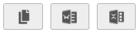 to export the view to the clipboard, MS Word or MS Excel.

NB: These buttons are not available in dashboards.

Click Save View
- Every view can be saved for reuse. Unsaved views are lost!
- Select an existing view (to overwrite) or enter a name (for a new view).
- Select the correct type:
  - Personal: only available for you
  - Local: available for everyone on this location (this project/program/portfolio etc.)
  - Global: visible to all users everywhere. (can be adapted only by administrators)
- Confirm with OK.

Custom Dashboards
With custom dashboards you are able to select projects across different portfolio’s and display them in one overview. Also, it’s possible to report about this selection and define read or edit rights.
To configure a custom dashboard:
- Navigate in the module Portfolio management to the section Custom Dashboards
- Within this section, click
- A pop-up appears. Fill in the name of your dashboard.
- Define the appropriate filters within the custom dashboard by clicking Set Dashboard Filter.
- Apply read- and edit rights under Edit Roles

Note: Custom dashboards must be activated in the configuration before your will be able to use them.
Widgets
Widgets can be used to display large quantities of data in one visual overview. Examples of widgets are pie charts or bubble charts. A broad array of widgets are available in different modules and levels in Fortes Change Cloud. To select a widget go to Edit widgets. Here you can select the desired number and type of widgets. Next you can click Configure to configure the widget.
Widgets can be configured by system administrators. Portfolio and custom dashboard managers are also able to configure widgets for their own portfolio’s and dashboards on the tab Dashboard or Dashboard Report

Year transition

You can set the current financial period in the Portfolio model and in a the Portfolio itself. By default the date is set as ‘--'. In this case the application will always use the current year in your Portfolio(s)

If a new year has started, the application automatically will use the current year because no year has been set. In this case you can’t make changes in the previous year. If you need to change the financial data in the previous year and also in the current year you manually have to change the current financial period and duration (See the quick guide Financial configuration).

NOTE: Changing the financial period in the configuration will have impact for all upcoming years. You have to change the date manually from now on.

If you want to adjust data from the previous year
Manually change the current financial year to a year in which you want to able to adjust the financial data. You can do this in the Portfolio model or in Portfolio itself.

NOTE: If you change the financial period in the configuration of the portfolio itself, you will have to change it every year in the portfolio itself. It will not take over the financial period from the portfoliomodel anymore.

If you want to adjust data from the previous year and the current year
You have to manually change the current financial year in the previous year and change the duration of the current financial period to 2 years. You can do this in the Portfolio model or in Portfolio itself.

If you have closed the financial year, you can change the current period back to 1 year and the financial period to this current year.

Now you have created a situation that you cannot change the current financial period back to --. From now on you have to manually change the current financial year for each annual transition.

Availibility Portfolio Models

Which portfolio models are available for your portfolio?
- All models created on the OU of your portfolio and in the OU above
- The models created in a different OU on the same hierarchy are not available for your portfolio

Help
Under the help button you can find the user manual and an overview of shortcuts.
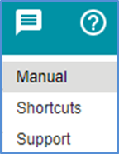

Release 1.0
http://www.fortes-online.com/

