

**Planning resources on plan-items**

1. Open the tab **Planning** tab in the project and select the tab **Resources**. Click in the top right corner.
2. Double click the field in the column **Planned Hours** of a plan item.
3. In the pop-up screen you can add resources to the plan item. The primary skill and Resource Pool are added automatically (unless a Resource is in more than one pool).
4. Resources can be planned on skill, resource or both. Manually enter the amount of hours.
5. The section **Resource Summary** shows the planned hours per resource and/or skill, per plan item.
6. In this section you can edit the planned resources and you can link the correct Resource Pool (for resources that are in more than one pool). If you planned one skill you can add resources.
7. Click **Save** to save the changes (button is not shown in the picture).   
     
   TIP: click on to view the Gantt or Resource Summary in full screen.  
   Note: depending on your configuration, planned hours will lead to planned costs.

***Quick Guide*** *Planning resources*

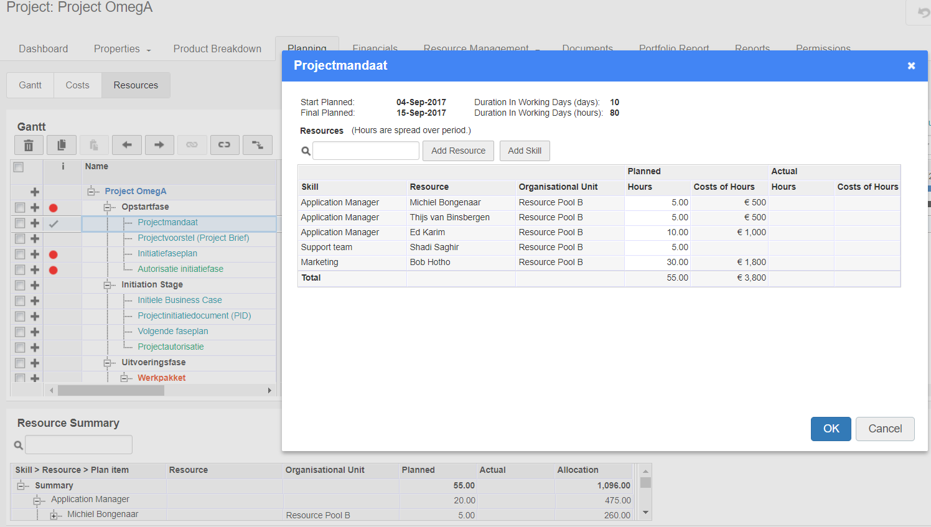

**7**

**5**

**3**

**4**

**2**

**1**

**6**



***Quick Guide*** *Requesting resources*

**1**

**Requesting resources**

1. In a project go to the tab **Resource Management** and click **Resource Allocation**.
2. The section **Request & Allocation** shows an overview per resource pool per resource of the planned, requested and allocated hours.
3. Click 

**Note**: After clicking the text changes to **Save** and **Cancel**.

1. ‘Planned hours’ on resources or skills are shown in the section **Request & Allocation.**

If Planned hours are not visible than check the

and change Resource allocation Process tot  **‘Hybrid’**

1. Click the green ‘**+**’ sign in front of the resource pool to add a row in which resources or skills can be entered.
2. To request a specific skill, select a skill in the drop down menu in the skill column in the correct resource pool.

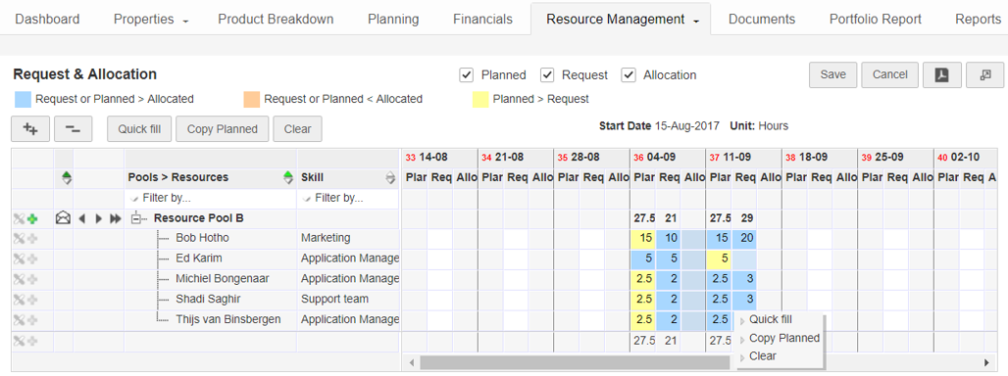

1. To request a specific resource (instead of a specific skill), select the correct resource in the drop down menu in the resource field in the resource pool.
2. Click and hold the left mouse button to select a range of fields.
3. You can perform multiple actions on the selection: **Quick fill:** fill selected fields with the same value   
   **Copy Planned:** Copy ‘Planned’ to ‘Requested’.

**Clear:** clear all values.

Note: Under **Help** you can find the available shortcuts.

1. Click **Save** to save the changes. This action sends the new or edited requests to the resource manager.
2. The resource manager allocates resources to match requests. The project manager can view this allocation in the column **Allocation**.

NOTE: See the legend in the top of the screen for the meaning of the colors.

**2**

**3**

**10**

**11**

**8**

**5**

**4**

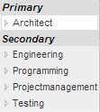

**6**

**4**

**9**

**7**

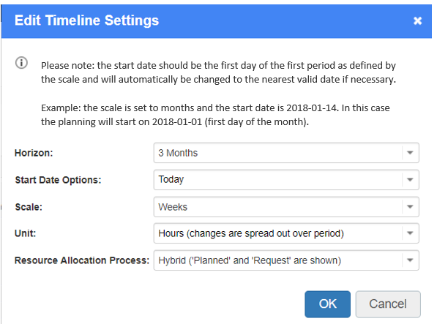

**4**



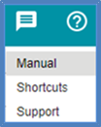

Under the help button you can find the user manual

and an overview of shortcuts.

Release 1.0

<http://www.fortes-online.com/>