Quick Guide
Functional Administration
Settings under Configuration
Go to Setup, Configuration
- Fortes Change Cloud: Setup for e.g.: Limited Roles on projects, extra tabs on Single Sheets, Manager can select his own widgets, it is only possible for Functional Administration to delete Orders
- Portfolio Management: Setup for e.g: Activate Custom Dashboards, Activate Scenario Planning, Start Projects from Portfolio and/or Folders
- Classic Project Migration: Setup for migrating ‘classic projects’ to ‘generic projects’ (classic project is end of life per PTB 9.0)
- Notifications: Setup for email notification on deadlines
- Conversions: Help table for use in custom timeline fields
- Hour Rates: Setup for managing master table Hour Rates
- Currencies: Setup to define currencies and currency rates
- Skill Categories: Create categories for use in (timeline) reporting
- Financial Categories: Setup for managing the master table Financial Categories
- Resources: Manage Resources (both with or without a user account)
- Skills: Setup for managing the master table Skills
- Time Entry: Setup for Time Entry configuration
- Entries: Manage Entries
- Non-project Activity Sets: Managing master table Non-project Activity Sets
- Resource Allocation: Set the resource allocation scale
- Customize fields: Create and manage Custom Fields
- Approval Entries: Manage approval entries
- Advanced Configuration: Manage widgets (for on premise customers only)

Create, configure and move Organisational Unit
Create an OU
Go to an OU in the tab Navigation, click , a pop-up appears. Fill in the name, define OU roles and click OK.

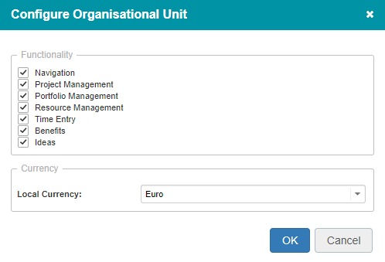
Configure an OU
Navigate in the OU to the tab Properties, click Configuration, a pop-up appears. Select which modules should be active in this OU. Select the available currency (see: ‘set currency’) and click OK.

Move an OU
Navigate in an OU toward the tab Navigation. Select the line of the OU that you want to move, click Move, a pop-up appears. Select the target destination of the OU and click OK.

Merge OU’s
It is possible to merge OU’s. The functionality to perform this has to be activated first. Contact Fortes Support for this.

Set currency
If you want to use different currencies you can define currencies and currency rates. Currencies can be applies to Organisational Units.

Set currencies
- Go to Setup, Configuration, Currencies
- Click Define currencies
- Click and fill in the data required for the currency
Set Currency Rates
- Go to Setup, Configuration, Currencies
- Click Currency Rates
- Define the currency rate, you can also add a start date for the currency rate

Set Currency per Organisational Unit
- Go to the OU and go to Properties
- Click Configuration
- Select the Currency

User administration
You can create user accounts and user groups. Groups are used to apply a selection of users to an OU instantly.

Create a user account
- Go to Setup, User Administration, tab Users.
- Click to add a user: enter the appropriate information in the pop up.
- When you’re done, click OK.

Change a username
- Go to Setup, User Administration, tab Users.
- Select the line of the respective user and click Edit account, a pop-up appears.
- Apply changes and click OK.

Create a User Group
Users groups can be given a role, just like you can adding roles to individual users.
- Go to Setup, User Administration, tab Groups.
- Click , a pop-up appears. Give the group a name and description, click Create Group
- Click on the name of the group, a pop-up appears.
- Click Add/Remove, a pop-up appears: add users, click OK.

Edit roles
Roles first must be assigned on OU (e.g. reader or member) and functional module level. Users that have a role on that level, can be assigned roles in the functional modules (e.g. project manager).

Edit roles on OU
- Go to an OU, tab Properties and click Edit Roles, a pop-up appears.
- In the pop-up click to assign roles on OU level and per functional module.
- Click OK and then Close.

Note: use the user group All Users to make everyone a member of the OU.

Edit roles on portfolio’s, folders, projects, and so on …
You can find the button Edit Roles on the tab Dashboard

Create a portfolio/folder
Create a portfolio
Navigate to an OU, tab Portfolio Management, click , a pop-up appears. Fill in the pop-up and click OK.

Create a folder
Navigate to an OU, tab Project Management, click , a pop-up appears. Fill in the pop-up and click OK.

Set tolerances on folders
You can set tolerances on a folder. Go to a folder, click on Edit Tolerances in right top corner of your screen. There are two types of tolerances that can be set:
- You can set tolerances for stages or the total number of plan items. The tolerances apply for all projects in the folder, for individual projects tolerances can also deviate. Tolerances can be set as a relative or absolute figure. Also, you can decide to only look at plan items/costs in the current stage of the project.
For Stage Planning Tolerance the number of stages which surpass the their planned delivery date is compared to the total number of stages. The tolerances can be set as an absolute or relative figure.
Product Planning Tolerance looks at the number of overdue plan items compared to the total number of plan items of the project planning.
- For Cost Tolerances the total actual costs are compared to the project budget.
- The Hour tolerances are not in working order and will be removed in the next releases.

Move a portfolio/folder/programme/project
Navigate to the item you want to move and select the line of the item. When the line is selected, click Move, a pop-up appears. Select the correct OU and optionally the correct folder, click OK.

Creating an idea/initiative/project
See QG Portfolio management for more information.

Planning and managing a project
See QG Project management for more information.
Archiving, restoring and deleting items
You can archive a OU, portfolio, portfolio-item, folder, programme or a project. Doing this will make these items visible in the tab Archive. This tab exists in OU’s, portfolio’s and folders.

Archiving items
- Navigate to the item you want to archive and the line of the item, click Archive, a pop-up appears. Click Archive again.
Note 1: Projects have to be archived in the modules Portfolio Management and Project Management. These are separate actions that must be performed manually in each module.

Note 2: When archiving items, all underlying items are archived as well. For example: when a folder is archived, all projects in the folder will be archived as well. The same goes for entire OU’s which can contain portfolio’s, folders and projects.

Restoring archived items
Navigate to the tab Archive, select a line and click Restore. A pop-up appears, click Restore again.

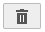
Removing archived items
Navigate to the tab Archive, select a line and click

WARNING: Removing archived items permanently deletes these items and all underlying items from Fortes Change Cloud. The data cannot be restored!

Creating a project model
A project model is a template for a project. You can create a project model by importing/exporting an existing model or by creating a model from an existing project.

Creating a model from an existing project
- In the Projects section, go to the program.
- Select the project on which you want to base the model.
- Click Model.
- Enter the data for the model.
- Confirm by clicking OK.
- The model is now displayed in the program, in the Project models section (under the Projects section).

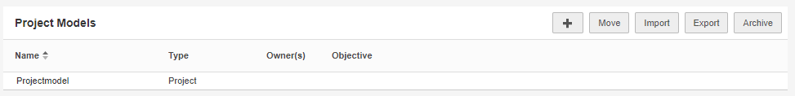

- Export and Import a Product model
  - Select the model in the Project Models section and click Export; Save the file.
  - Go to the Organisational Unit with Project Management, to the tab Models.
  - Click in the Project Models section Import, select your Project model and enter the data in the pop-up screen and click OK.

Configuring a project model
You can configure the following elements of a project model:
- Tab Property page layout see ‘Editing page layout’
- A planning (stages/plan-items) see QG Project management
- Page layout of plan-items see ‘Editing page layout’
- Automated reports see ‘Creating templates for…’
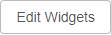
- Widgets on tab Properties and tab
Reports, click Edit Widgets
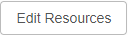
- Linked resource pools on tab
Resource management, click Edit Resources.
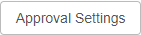
- Plan-item approval on detail page of
a plan item, click Approval settings
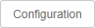
- Behavior of costs, hours and time entry on tab Dashboard, click Configuration See QG Financial Configuration
Some caution when adjusting a project model:
- These changes do affect existing projects: Property page, existing automated reports, plan-item approval, plan-item custom page layouts, widgets, cost and hour behavior
- These changes do not affect existing projects (with that model):
Planning, linked resource pools, new automated reports.
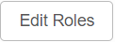
- These change do not affect existing or new projects (with that model):
Roles that have been selected in the Project model

Availability of the Project model when starting a project
When you start a project you first have to select the OU and a Folder.
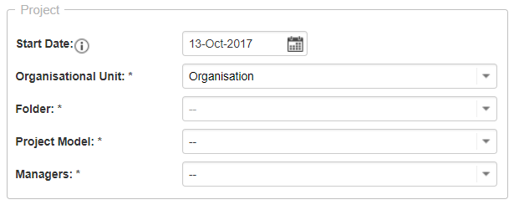

Based on the selected OU and folder the following project models will be available:
- All models in the selected folder (Model saved in this folder)
- All models in the folder above the selected folder in the same OU (Model saved in above folders in same OU)
- All models in this the selected OU (Model saved in this OU tab Models)
- All models in above OU’s (Model saved in OU tab Models)

The following Project models will not be available:
- Models saved in the folder next to the selected folder (model saved in that Folder)
- Models saved in a folder in a OU above the selected OU (model saved in a higher OU in Folder)

Permissions
It is possible to hide specific parts of projects for specific roles. Using the permissions provides the opportunity that users only see the parts what they need.

These parts can be tabs (Dashboard, Properties, History, Taskboard, Product decomposition, Documents, Portfolio reports, Automated reports), planning related elements (Backlog, Gantt, Costs, Resources) Resource management (Overview, Approve Hours, Resource Allocation) and Logs (Issues, Risks, Quality Reviews, Changes, Actions, Lessons Learned, Minutes of meeting, Orders)

Configuring permissions
You can configure permissions in two ways: in the Project Model or in the individual Project.
- Go to the tab Permissions in a model or a project
- Click on edit 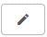
- By ticking the boxes you can hide or show tabs and logs per project role. You can change settings per role or per group of roles.
- Click Save to apply the changes.

Note: You can allow the role Project Manager to edit the permissions in the project itself. To do that, in a Project Model on the tab Permissions, check the box Allow Project Managers to override this configuration on the project. The tab Permissions will now also appear on the project.

Note: Permissions can be set for project roles only; as an administrator the permissions do not apply.

Single sheet projects
Single sheet projects are ‘one page‘ projects. There is no Gantt chart and there are no logs, but you can save documents. A single sheet project at first is empty. From a portfolio you can send a report request, which will become the ‘one page’. With a single sheet it is possible to:
- Manage projects on one page
- Perform resource allocation
- Perform time writing
- Report to the portfolio
Singe sheet projects are recognisable by the 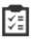 icon and are started with a Single sheet project model.

Start a ‘regular’ project from a single sheet project
A single sheet project shows the button Start Project with which you can apply a regular project model. Note that when there is an open report request, that button is replaced by the button Publish to portfolio.

Creating a portfolio model
Fortes Change Cloud comes with a standard portfolio model. You can create extra portfolio models in the tab Models, in the section Portfolio Models.

For more information on configuring a portfolio model, see:
In the portfolio model the followings things can be configured:
- Page lay-out of portfolio items (see ‘Editing page layout’)
- Report models (see ‘Creating a report model’)
- Automated reports (See ‘Working with automated reports’)
- Field configuration (See QG Custom fields)
- Financial configuration (See QG Financial grid)

The configuration of a portfolio model applies to portfolio’s based on the model. However, in a portfolio it is possible to deviate from the model configuration.

Creating a report model
A report model can be used to have projects report to the portfolio. Report models are part of the portfolio model and are found in the section Report Models. In that section you can create, import/export and manage report models.

Click the name of a report model to open it. A report model has the following buttons:

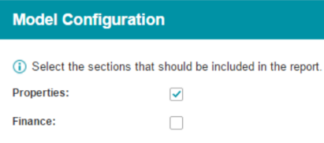
Click on Page Layout to edit the contents of the report model (see Editing page layout). Click Model Configuration to select whether the report model should contain a properties section and/or a financial grid.

Note that the financial grid will follow the financial configuration of the portfolio (see QG Financial Configuration) .

Editing page layout
Within the Portfolio, Report and Project Models it’s possible to customize the layout of pages.
- Portfolio: Portfolio-item layout
- Report: Report Layout
- Project: Tab Properties, plan-item pages and logs

Editing page layouts
Example: the project tab Properties
- Go to the project model, tab Properties, click on Layout, the Edit Layout, a pop up appears.
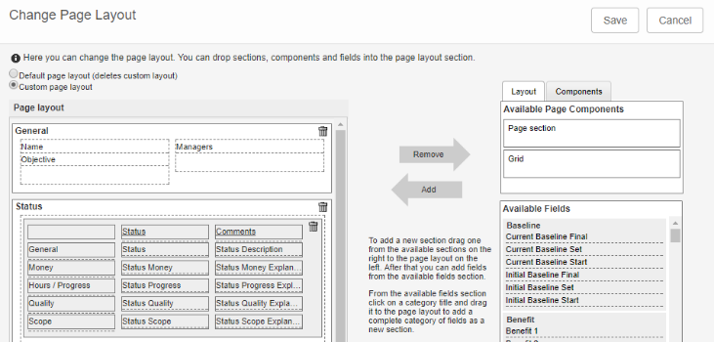
- Use drag-and-drop to add page sections, then add grids and or fields. You can also add grids (tables) and labels.
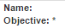
- To make a field mandatory, double click the field, a pop-up appears, select ticket box Required 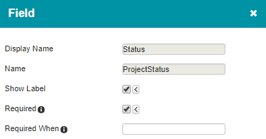
Note: mandatory fields are marked with a ‘*’ . Pages can only be saved when all mandatory fields have been entered.

- Double click on a page section (outside of the dotted lines) to edit the properties of that section. Here you can also change the color of the section.
- When you’re finished, click Save.

Special: use rules for the page layout of plan-items
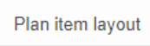
- Go to the project model, click on
the tab Plan item layout
- You can add and rank rules for page layouts. For each rule you can define a filter for which plan-items it applies and define the page layout.
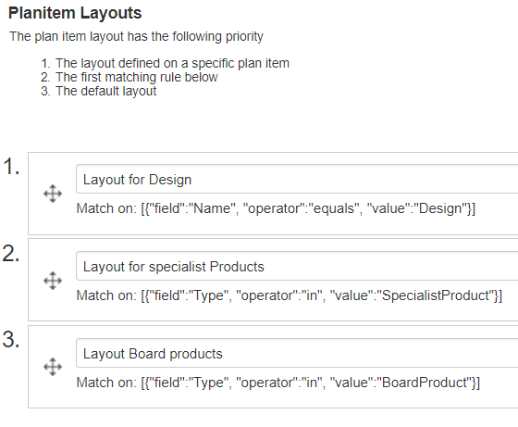

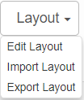
Export/import existing layouts
You can export page layouts and import them somewhere else:
- Click on Export Layout and save the file
- Click on Import Layout and select the file

Note that layouts can only be imported on the same object type.

Editing and saving views
On tabs, reports and logs you can edit and save views. Under the button View you will find the following possibilities:
Set Filter: Configure filters on the view
Set Columns: Select the columns in the view
Set widths: Adjust column widths in view
Chart Options: Show view as graph
Advanced: Advanced setting (for example totals)
Make default Make default
Save view: Save view for user(s)
Manage views: Manage the properties of views

Click Set Columns
- You can add or delete columns by means of drag and drop. The order of the columns can be edited in the same way.
- Add a sorting and confirm by clicking OK.
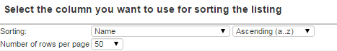

Click Set Filter
- You can filter the data in a view by setting one or more filters.
- Click Add filter, select the filter-field and set the filter and confirm with OK.

Click 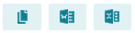 to export the view to the clipboard, to Word or to Excel.

Click Save View
- Every configured view can be saved for users. Warning: unsaved views are lost!
- Select --new view-- or select an existing view. Enter a new name for the view.
- Choose the type Personal (for personal use), Local (for all users on this location in the Fortes Change Cloud), or Global (for all users system wide), and confirm with OK.

Working with automated reports
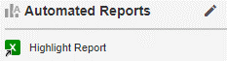
You can generate reports/documents with Fortes Change Cloud based on templates. The available reports can be found in the Automated Reports section on the Dashboard tab and on the Reports tab.
- Click the name of the desired report.
- Warning: Excel reports should always be saved before opening.
- Allow macro’s (in order for the report to fill with data).

Creating templates for automated reports
See the QG Reporting.

Widgets
Widgets can be used to visualize data. Examples of widgets are pie charts or bubble charts. Different widgets exist on different levels in different modules throughout Fortes Change Cloud. To configure widgets, go to Edit widgets. Here, you can select the number and type of widget(s). Next, you can Configure the widget itself. This is different for each type of widget. You can use the filter to apply additional filter options.

Widgets can be configured by administrators. You can allow users with the role Manager and Coordinator to configure widgets (under Setup > Configuration).

Custom fields
Custom fields can be used to register specific data that does not fit in the (regular) system fields. These fields can be used in dashboards, views and reports.

See the QG Custom fields for more information on:
- Creating custom fields
- Custom field properties
- Behaviour of custom fields
- Use of custom fields

Last login date of users
To see the last ‘login date’ of a user:
- Go to Setup, User administration
- Go to View and click Set columns
- Select the column Last login date

Help
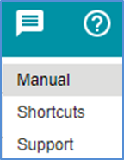
Under the help button you can find the user manual, an overview of shortcuts, and a link to the Fortes Support Portal. Note that you can only log in to the support portal from your production environment.

http://www.fortes-online.com/

