Quick Reference Card
Financial Configuration
Introduction

The financial administration of projects and programs forms the basis for the steering of projects, programs and portfolios on money. In the Fortes Change Cloud the ‘financial grid’ forms the foundation for monitoring of reservations, budgets, actuals and forecasts of projects.

The report cycle between projects, programs and portfolios is used to exchange financial information. This process is configurable in multiple ways. A common scenario is:
- Releasing budgets from the portfolio to projects or programs.
- Import the actual project costs from a financial system (possibly partially from the module time entry).
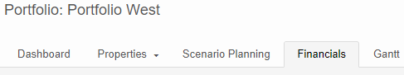
- Report of forecasts per project or program to the portfolio
The financial grid
Every portfolio and project has a tab Financials. This gives an overview of the financials of the projects or programs in the portfolio: the financial grid. The grid displays budgets, actuals, etc. per financial period (year, quarter or month). In a project the financial grid is available on the tab Financials.

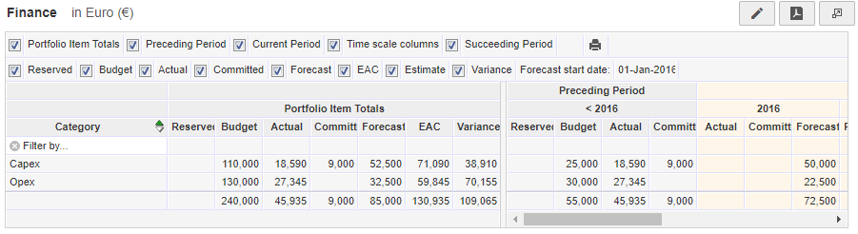
The financial grid is divided in three periods:
- Everything prior to the current financial period
- The current financial period
- Everything following the current financial period
The left side of the screen shows the project totals: a summation over all periods. Every period contains a number of columns that can be switched on/off with the flags in the top right corner. The following paragraphs provide a more in depth explanation of the columns.
Remark: The financials of archived projects will stay visible and are shown in red on the tab.

Set currency
When the multi-currency module is activated you can set currencies to be able to report in one currency.
Set currency
- Go to Setup, Configuration, Currencies
- Click Define currencies
- Click and fill in the data required for the currency
Set Currency Rate
- Go to Setup, Configuration, Currencies
- Click Currency Rates
- Define the currency rate, you can also add a start date for the currency rate

Set currency per Organisational Unit
It is possible to set a currency per Organisational Unit.
- Go to the Properties tab of an Organisational Unit.
- Click Configuration
- Select the Currency
- Save changes by clicking OK.

Financial categories
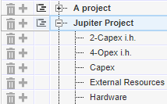
In the financial grid you can display the project or program financials using financial categories (for example CAPEX, OPEX, hardware, software, etc.).

Click Edit (top right) and click in front of the project or programme name to add financial categories to a project. With the sign they can be deleted.
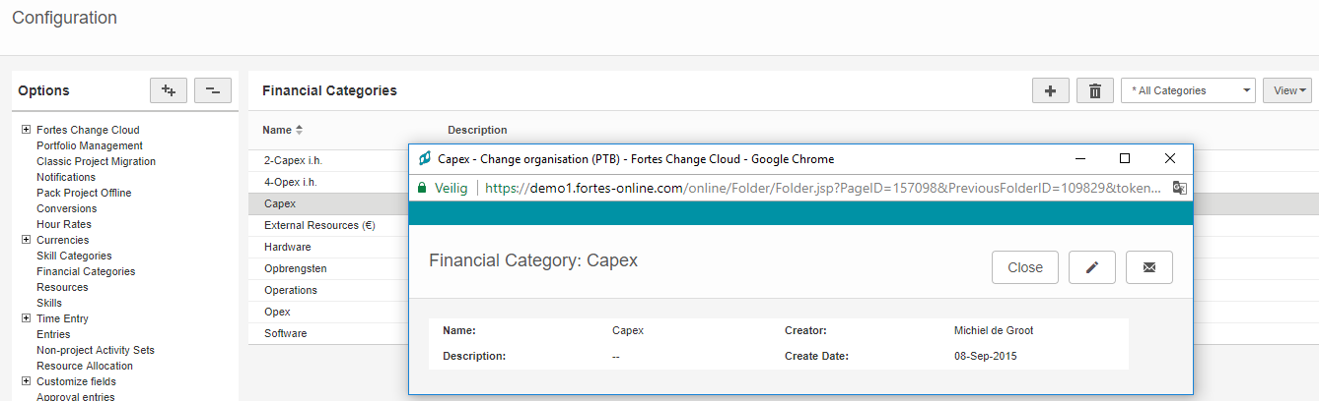
N.B.: creating financial categories works as follows:
- Go to Setup and select Configuration.
- Click in the left side of the screen on Financial Categories. The screen displays the available categories.
- Click
- Enter the name and description and click Save.

Columns: Reserved
The column Reserved is used for budget that has not been released yet. This column is often entered by the portfolio manager. From the reservation, the budget can be gradually released to the project or program manager.
The column Reserved can also be used to enter reservations for the initiatives of the following year. During the year you can compare actuals and forecasts to the reservations.
Columns: Budget
The column Budget is used for the approved project or program budget. The budget is often entered in the portfolio and is visible for the project or program manager.

You can also use the column Budget to ’release’ the budget per stage.

Columns: Actual
The column Actual is used for realised costs. Data can be entered into this column in multiple ways:
- Manually.
- Imported from a financial system.
- Based on the module Time Entry (in the Fortes Change Cloud you can link a rate to resources which enables you to translate actual hours into actual costs).

Columns: Forecast
The column Forecast is used for the expected costs of ongoing projects or programs. The Forecast is often entered by the project manager (in the portfolio report) and displayed in the portfolio.
The project or program manager gives a forecast for the current and the following financial periods. There are three settings possible for entering the forecast for the current period:
- Forecast for the remaining costs of this year,
- Forecast for remaining costs per month,
- Forecast for the total costs during the current year.

WARNING: Remaining costs are the expected costs from the Forecast start date to the end of the current financial period. The forecast start date is determined automatically when a report request is send from the portfolio and can be edited manually.

Remark: Ideas do not have a project manager. The portfolio manager can enter forecasts on the portfolio side, enabling him to compare the total forecast with the total reserved.

Columns: Estimate

The column Estimate displays the result of the following calculation; Estimate = Actual + Forecast for the current financial period.
Columns: Committed

Columns: Estimate at completion (EAC) en Variance
The column Committed is used to capture the commitments made for ongoing projects and programs. Commitments are mostly imported from the financial system but can also be entered manually.
The column EAC shows the result of the following calculation: EAC = {sum of all costs before the forecast start date} + {sum of all forecasts after the forecast start date}.

The column Variance shows the remaining budget based on the following calculation: Variance = Budget – EAC.
The column Last Published On shows the publication date of the most recent forecast of the project manager.

Remark 1: The EAC calculation neglects costs with a booking date at or after the forecast date.

Remark 2: The Forecast start date can differ per project and is dependent on the last published report request. The content of the columns Variance and EAC is based on the Forecast start date of the project or programme itself.

You can adjust the availability and behaviour of the columns in the financial grid. You can also set the timescales of the previous, current and upcoming financial periods and adjust which financial categories can be used.

Finance configuration (portfolio model)
The financial configuration is configured in the portfolio model. You can create different configurations per individual portfolio.
PLEASE NOTICE: Financial configuration is also possible in the project model, this is only effective when the configuration in the portfolio(model) is set to be editable.
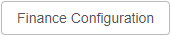
Finance Configuration:
- In the tab Financials click Finance Configuration.
- Set the periods that have to be displayed in the overviews: start, timescale, duration and summations.
- Set the behaviour (adjustability) of the financial types/columns and set the desired detail level for the current period.
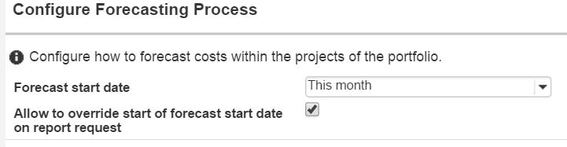
- Configure the forecast process and the edit ability of the forecast start date.
- Determine what financial categories can be used and determine if categories without data should be displayed (Set display options)
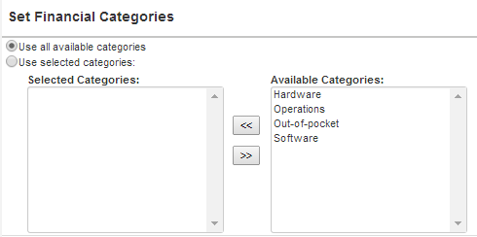

- Configure if entries of achieved projects and programs are shown in the financial grid. You can also only show the entries of achieved projects that relate to the current period.
- Click OK to save the financial configuration.

Finance configuration (project and programme model)
Just as in the portfoliomodel, you can adjust the behaviour and visibility of financial types in the financial grid. The financial configuration in the (portfolio)model is always leading compared to the configuration in the project or programme model

Also, you can configure where costs can be entered in the project and/or programme model. (financial grid, planning, order log (if available)).
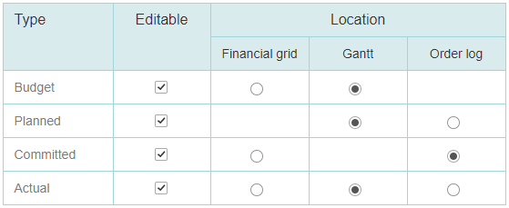

Financial reports on the portfolio

The portfolio manager can send a report request for (a selection of) projects and initiatives in a portfolio. In the tab Portfolio reports of the project the reports can be entered by the project manager. If the project manager then clicks Publish to portfolio the project information in the portfolio will be updated.

In the Report model you can configure whether a report request does or does not contain the financial grid:
- Go to the Report model.
- Click Model configuration.
- Select Display finance section.
- Click OK to save the configuration.

Remark 1: Report models are configurable in the portfolio model. You can set multiple report models per portfolio.

Remark 2: After sending the report request the financial grid appears on the tab Portfolio reports of the project.

Reports
- You can set reports, widgets and automated reports (Excel) to display financials of projects and portfolios. A quick method for this is the configuration of a widget:
- Go to a portfolio, tab Dashboard, click Edit Widgets.
- Flag Show widgets and select the type Timeline Chart.
Click Configure in the widget and customize the widget as desired

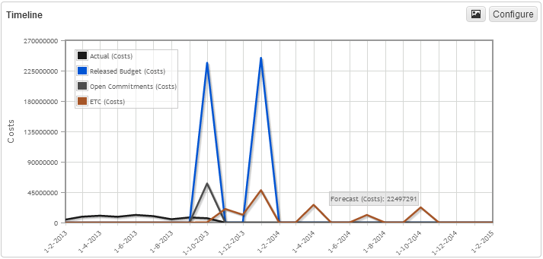

Year transition

You can set the current financial period in the Portfolio model and in a the Portfolio itself. By default no date has been set, the value is showed as --. In this case the application will always use the current year in your Portfolio(s)

If a new year has started the application automatically will use the new current year because no year has been set. In this case you can’t make changes in the previous year. If you need to change the financial data in the previous year and also in the current year you manually have to change the current financial period and duration.

NOTE: Underneath adjustments in the configuation will have impact for all upcoming years.

The need to able to adjust data from the previous year
Manually change the current financial year to a year in which you want to able to adjust the financial data. You can do this in the Portfolio model or in Portfolio itself.

The need to able to adjust data from the previous year and the current year
Manually change the current financial year in the previous year And also change the duration of the current financial period to 2 years. You can do this in the Portfolio model or in Portfolio itself.

If you have closed the financial year, you can change the current period back to 1 year and the financial period to this current year.

Now you have created a situation that you cannot change the current financial period to back --. From now on you have to manually change the current financial year for each annual transition.

Help
Under the help button you can find the user manual and an overview of shortcuts.
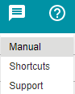

Release 1.0
http://www.fortes-online.com/

